专业基础课+基础英语写作+19英语A2谢尚南+20191120714
Notes on basic English writing class
class one（10.12）
self-examination:
I can only use block comparison in writing composition, not point by point comparison. I can't use this method very well. In the next exercise, I will try to use the second type of composition as much as possible. There is another problem, I always write a composition is always top heavy, the beginning is too long，I will correct this problem.
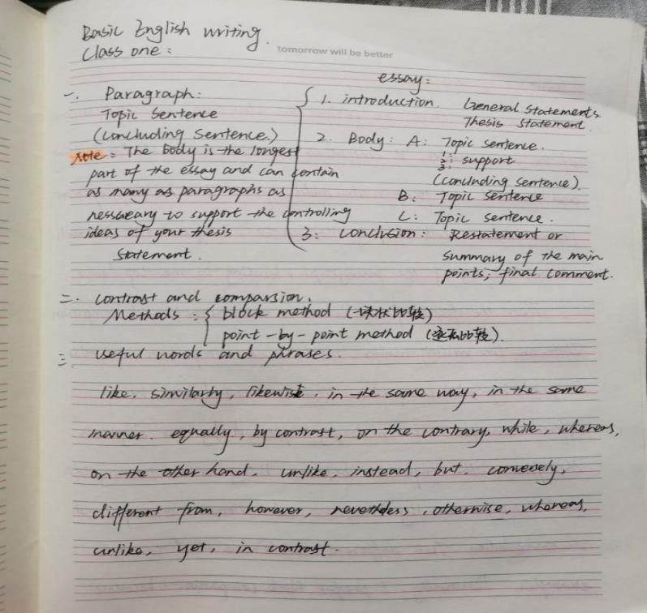
Reflect：
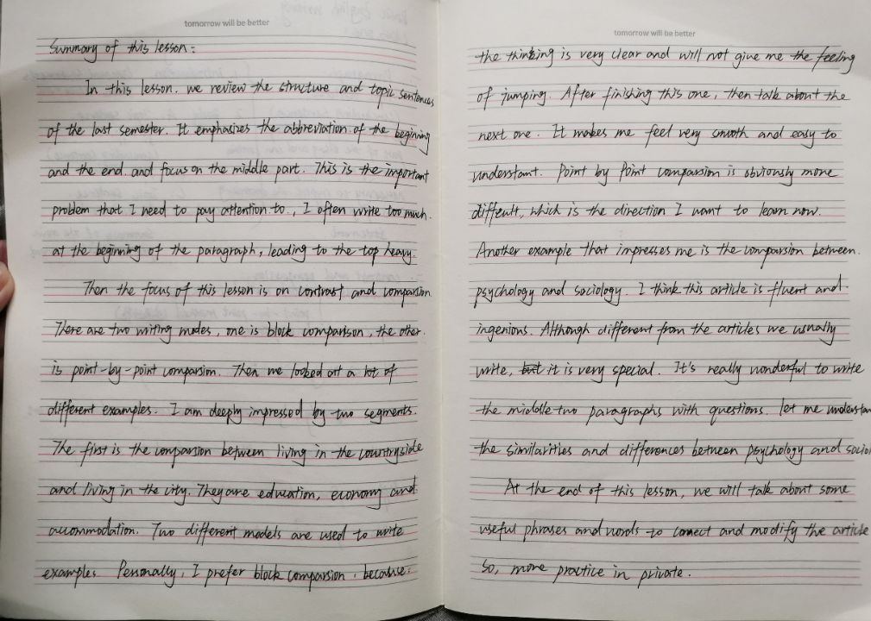
class two（10.20）
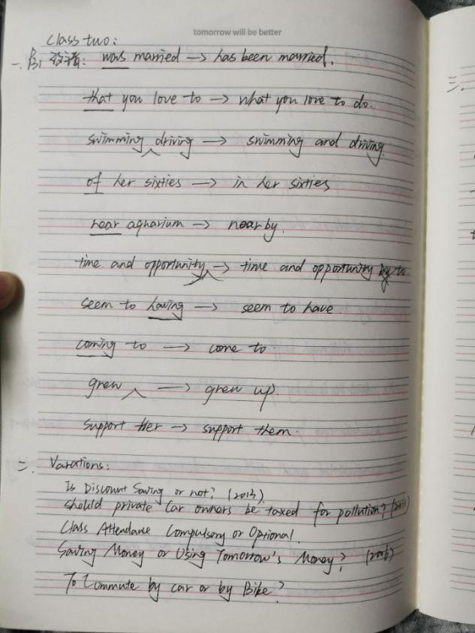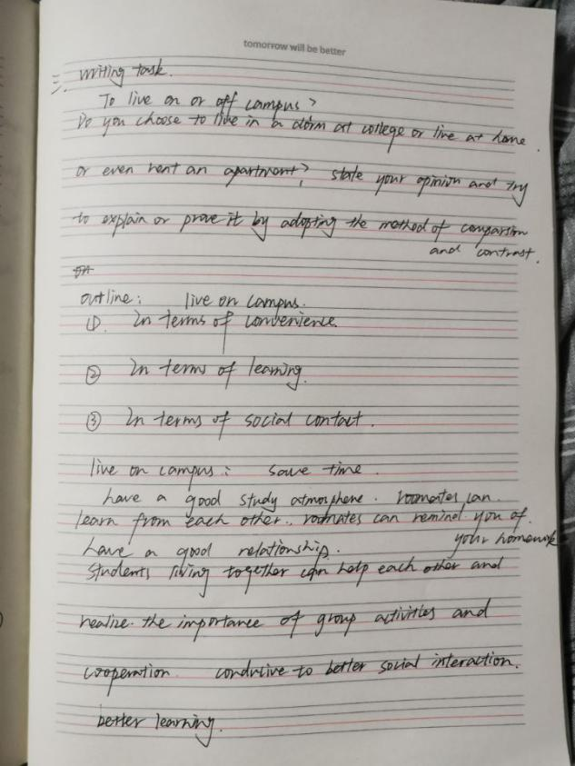

Reflect：
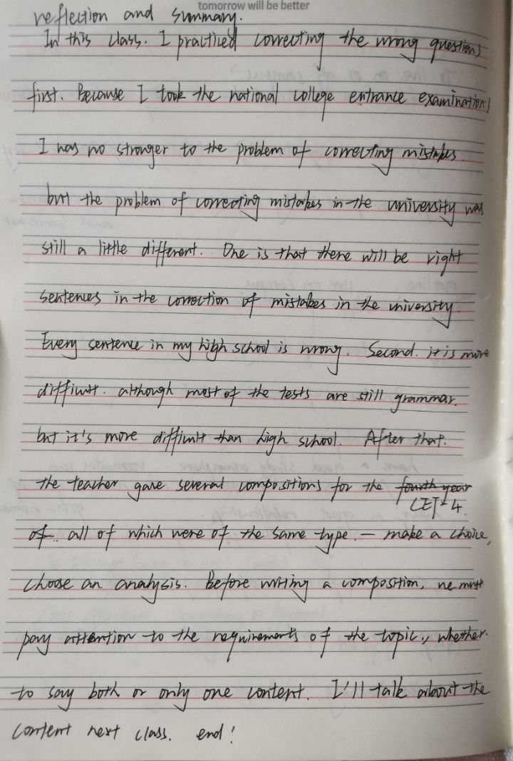
class three（10.26）
Reflection and summary：
Today I talked about the cause and effect in the composition. This is a type I'm familiar with. I usually write more about the form of one cause and many results. For example, we often write about a series of problems caused by environmental pollution, such as the extinction of organisms, the destruction of the ozone layer, and the threat of human life safety. This is a typical one for many reasons.
There is also a kind that we are very familiar with, that is, the same article content, asking the cause of environmental pollution, we can answer from many aspects, factory waste gas, waste water, automobile exhaust, chemical fuel combustion.This is the type of multiple reasons for one result.
I haven't written much about the other contents today. One is that there are many causes and many effects，and the another is causal chain pattern. In future exercises, I will pay more attention to these two types of articles. One reason corresponds to the other. The result is relatively easy to write, but the other is very difficult. If there is no good logic and clear mind, the relationship chain will be very messy.
There are a lot of gains in today's class. I read a lot of examples, which are all about causal types. Each article has its own characteristics. The teacher said that it is best to let people know what parts of the following content are in the first paragraph.

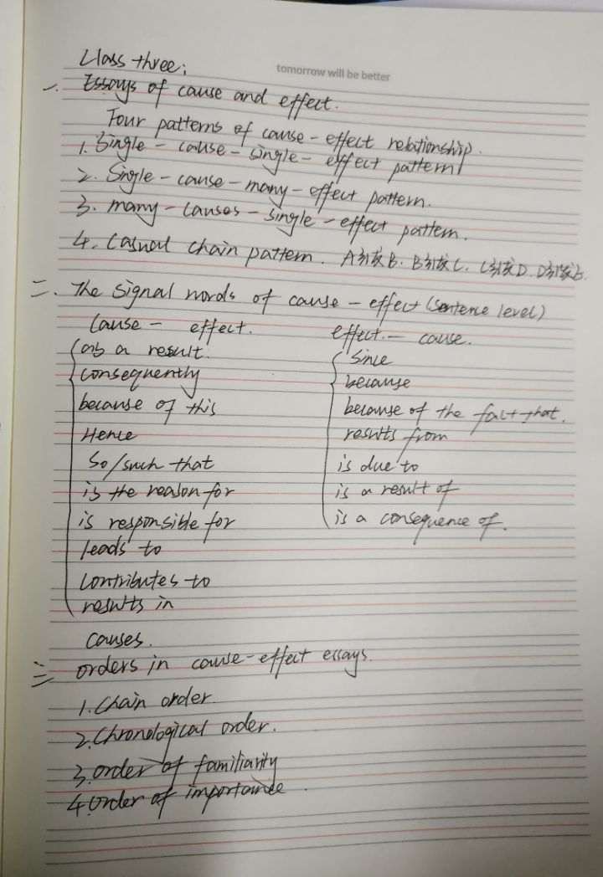
class four（11.2）
Today's basic English writing course is very substantial. First of all, the teacher talked about the homework left over from the last class. There are three contents in the assignment. The first one, We need to read the article carefully to find out the reasons and influence corresponding to the topic. This question I do or good, the answer is basically correct, the article also understands better. The second question is to fill in the blank, this question I do not do well, after class to reflect on, one is that I do not grasp the phrase well, the second is the article did not understand, so it is so much wrong. The third topic is to correct mistakes, this problem completed in general, after listening to the teacher can understand why the error, but do not do it yourself.
Then in this class, we enjoyed two good articles. One was cultural conflict. The teacher asked us to summarize the outline. One is the rise of sea level. In my opinion, these two articles are really good and well organized, which are worth learning from.
Finally, the teacher asked us to practice an article, become a member of the university community. I think it is more obvious advantages to join a club, so the topic I choose is the benefits of being a member of a university club. I analyze it from two aspects: one is that joining a student association can make more friends and expand our social circle; the second is that joining a student association can improve our abilities in all aspects. I chose the two most prominent advantages, and these two aspects are the best to start with. That is all.

class five（11.9）
Feelings：
In this class, the teacher talked about narrative style. This class is mainly to appreciate, we appreciate a lot of model essays.I was deeply impressed by Einstein's model essay, because after I read the article carefully, I thought that the article was well-organized and echoed from the beginning to the end. I remembered what the teacher had said about writing a composition. Start and end with fewer words. Especially at the beginning, it is better not to exceed 15 words. This article is very in line with the requirements, the beginning and the end are very concise, a good introduction and summary of the content of the article.
Then I was impressed by the article about amusement park. The teacher also said that this article was chosen because it was very similar to the narrative we wrote when we were children. I feel the same way. After reading this article, I realize that the original simple narration of an amusement park can also be written well. The narrative I write is like a running account. That's how I write Chinese, let alone English composition.

Reflect:
I think it's very difficult to write narratives. It's easy to tell a story, but it's hard to tell a good story. This is also the most important issue for me now. I can write a composition, but it is very difficult for me to write a good composition. I have a small vocabulary, which is also a key problem, and I can't use words. In the first assignment, the teacher also said that my words were not good enough and my language was not exquisite enough. I need to pay special attention to these issues.
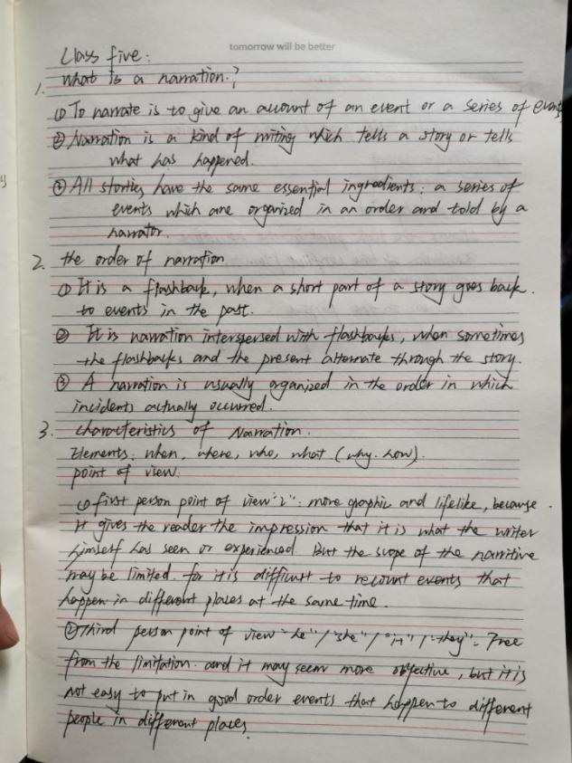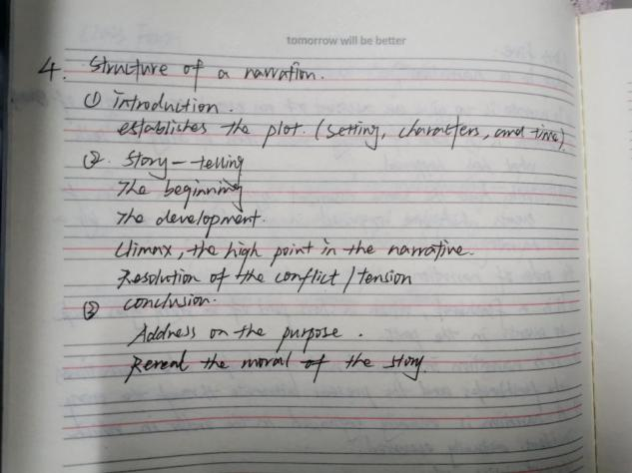

class six（11.16）
Reflect:
Today's class content is mainly to comment on the composition, read many students' excellent composition, some students write a very good topic, a sentence summary of the full text, accurate points. Some students' compositions are well written, with complete structure and clear logic. Some students have good composition language, can express their ideas with accurate language. This is a very important point. Because I handed in two assignments, the teacher gave me a serious comment, two times mentioned that my composition language is not good enough, I hope I can write the language more accurately.
In the second class today, the teacher talked about expository writing. I read several examples. I think expository writing is more difficult than argumentative writing. I can't tell the difference between the two styles in English composition. So I checked the materials and found that there are seven kinds of expository writing in English.
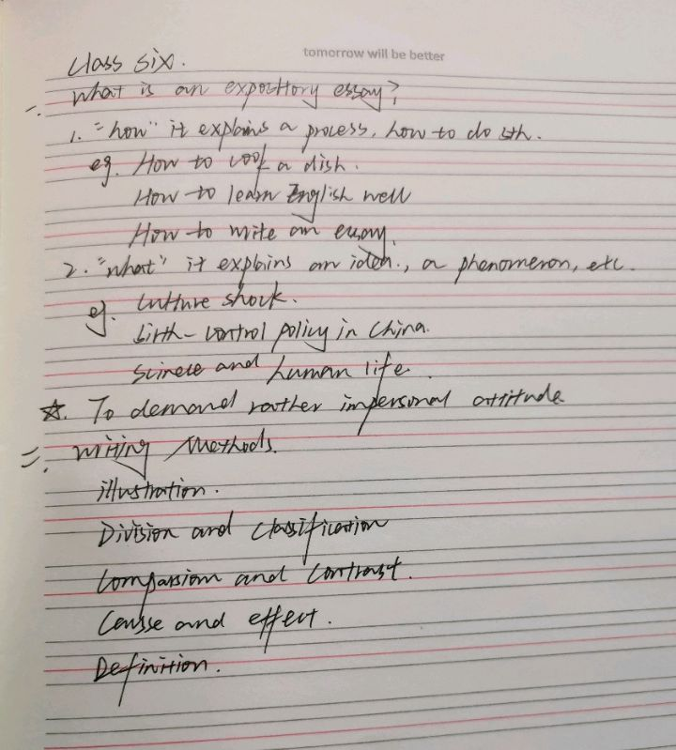

class seven(11.30)
​ Today, I study descriptive writing, mainly appreciating and reading some model articles. There are several articles that I'm quite impressed with. I'll record and share them here. The first model article is a paragraph, which describes the scene that a person is very sleepy after dinner. It is very simple to explain before modification. It can be expressed clearly in a short sentence. After the modification, I was surprised that the author used rich adjectives to vividly show such a picture. I think this is the charm of descriptive writing.
The second segment is about a person eating an apple. There are two demonstration articles. The first one I like better, because the adjective is just right, which makes me feel that the apple is really delicious, and there is an impulse to buy an apple. Although it uses exaggeration, it has a good effect of enriching the composition. The description of the second article is a little too full, which makes me feel uncomfortable. But today after class, I went to the fruit supermarket to buy two apples. The next model article is excerpted from "if you give me three days of light", describing the heroine Helen Keller's feeling of nature. She can feel her happiness between the lines and usage of bright examples'
The title of the last article is the transformation. Opening point：Money does make the man. Closing point：Pride is the vital ingredient in self respect

Reflection:
Today's study of descriptive writing, I think that if I want to write a good description, I can't do it with my present ability. In my opinion, I must have a rich vocabulary and a high English writing ability to complete a good descriptive article.
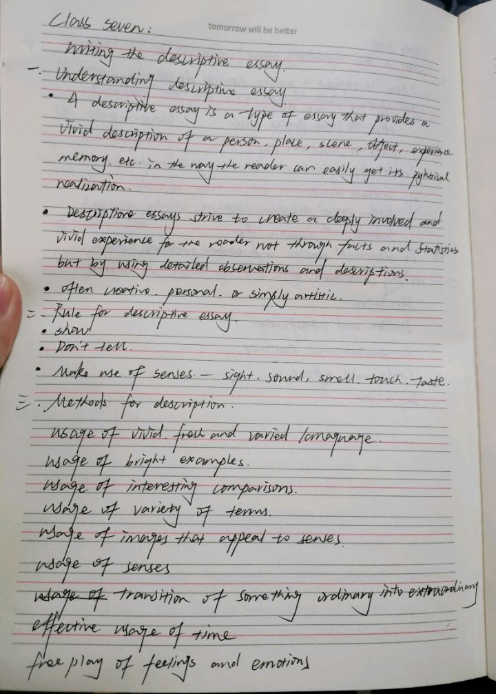
class eight（12.7）
Reflect：
In this class, the teacher first commented on the group work of last week. It's a great honor for our group's work to be praised. The beginning and the end echo and are concise. The first inner part is well written. The bad part of the whole composition is the external content of the second part. The teacher said that there was too much empty talk, there was no specific explanation and key content. As the editor of the whole composition, I seriously reflect on why the first paragraph can be written well, but the second paragraph is not. Because I asked two people to write the same content when I arranged the content. For example, the internal part was written by two students at the same time. Finally, I summed up the parts that were well written by two people. The second part of the external content, not because the two students did not write well enough, but because both of them have different ideas. It is difficult for me to integrate. This is a problem. The second problem is that I did not adjust the content well, so the effect is not good. This is a summary of the group work.
Next, I will talk about the content of expository text. Today, the most harvest is to judge the topic of expository text. For example, judge whether a topic is controversial, and if so, write an argumentative paper. Our subjective view of a person or a thing is not controversial. Therefore, it is very important to choose a suitable topic.
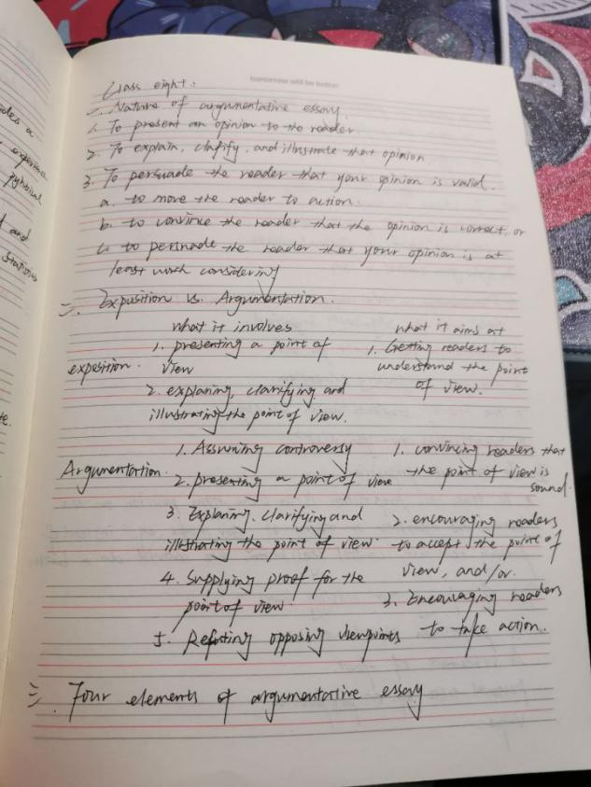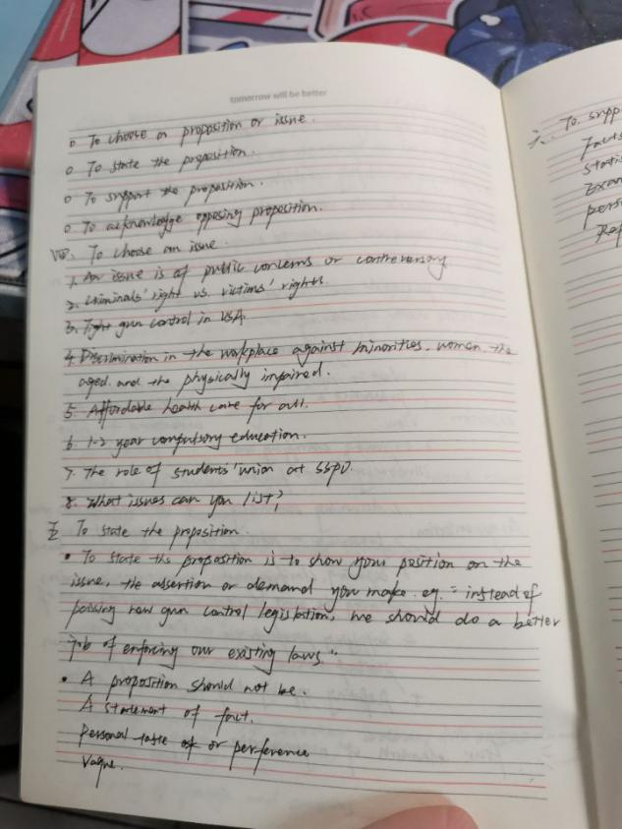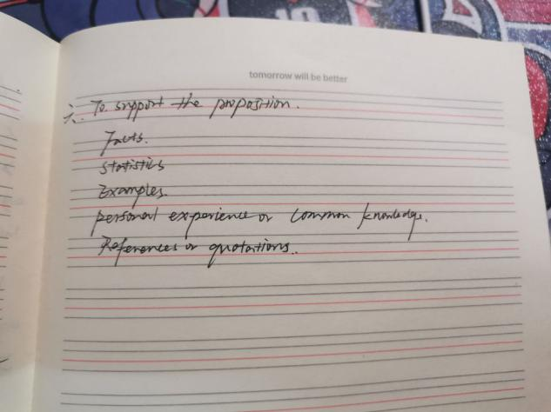

class nine（12.14）
Reflect：
Last class, the teacher left an assignment, which is to read an article in the textbook, and then write its outline. Today's reflection is that I didn't finish my homework well after class, so I didn't finish it at the weekend. If I didn't read an article in advance, the effect of the class would be greatly reduced by half. In the future, we must finish homework after class, pay attention to preview, read more and think more.
Then this class also talked about reasoning. The teacher introduced reasoning in detail. We also read several examples together to get a good understanding of reasoning. In this class, we assigned a group work to finish an English composition. After a heated discussion, we roughly discussed only two key points. The topic of the composition is whether to strengthen the supervision of learning and examination. The result of our discussion is that we should strengthen the supervision of learning and examination. Write about the school and the individual.
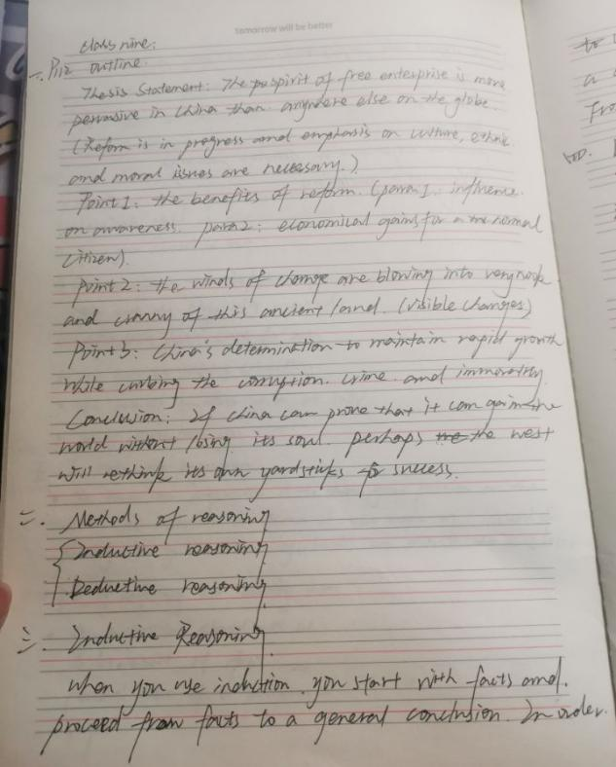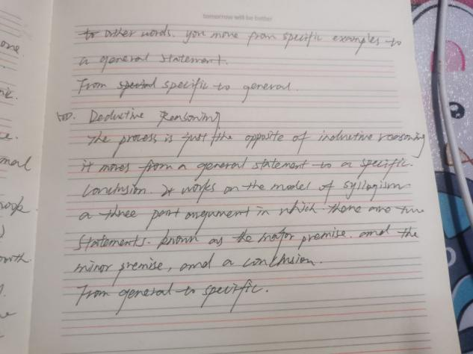

Class ten（12.21）
Notes：
Today, the teacher talked about the key points of summary,
①Basics of a summary
a condensation of the main ideas in an article
to give readers an objective complete accurate and balanced view of an article they have not read
1/ 3 or 1/ 4 of the original
②Essentials of summary writing
Read and the main ideas of the article(thesis statement in the introductory paragraph, and topic sentences in the body paragraphs).
Arrange these ideas carefully for balance and completeness
Use your own words as much as possible.
Reduce explanation and illustration to the essential minimum.
③Skills required
Reading comprehension-accurate understanding
Outline-the relationship
Paraphrase-retelling
De-description conciseness

Reflect：
Because I have never been exposed to the summary question before. Therefore, this question type is very strange to me. After listening carefully in class, I understood the three key points of summary: accuracy, integrity and objectivity. Finally, pay attention to balance. After reading several examples, I think it is very difficult to make a summary. It's not a simple acronym. First of all, I need to read the article, find the key points, and draw them out in the text. After that, I need to rewrite the sentence, which is very important because I can't copy the original sentence. So it is very important to have a certain vocabulary and sentence pattern.
My biggest problem is that I can't rewrite sentences. I read an article with preconceptions. This sentence pattern has always been reflected in my mind, which makes me unable to remember other sentence patterns and other appropriate word replacement. Of course, sometimes I can't grasp the focus of an article, so I can better understand the information that this article wants to convey to you by reading it carefully.

