课外阅读：《The Thirty-nine Steps》作者：约翰·巴肯
出版社：新星出版社+参赛者：谢尚南+20191120714（学号）

when、where、who
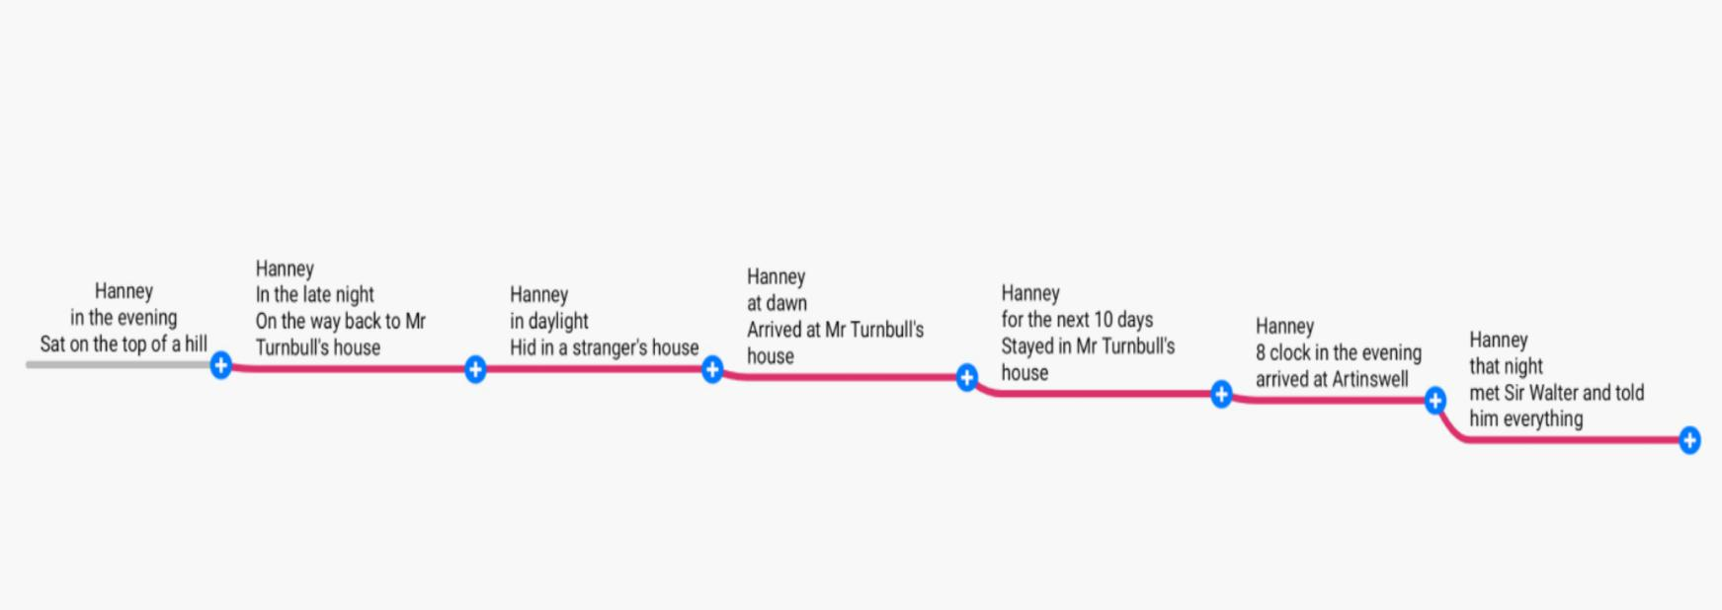
Synopsis of this chapter：
In this chapter, the protagonist is in a difficult situation. In the first half, it describes the life of the protagonist after his escape. He is injured and has a splitting headache. He has to walk a long way to reach the place he wants to go. Fortunately, the road mender took care of the hero for more than ten days. After his injury recovered, he left here and went to the south. Then he meets another key character in this chapter, fisherman. The protagonist has a simple conversation with the fisherman, and realizes that maybe the amiable and astute man is his real comrade in arms, but the result is not that the fisherman is the helper that Scudder has found to help the protagonist finish his task.

在本章中，主人公的处境比较艰难，前半部分它描述了主人公逃跑后的生活，他受伤了，头痛欲裂，他要走很长的路才能到达他想去的地方。幸运的是，修路工人照顾了主人公十几天，主人公的伤势恢复后，他就离开了这里去了南方。然后他遇到了本章的另一个关键人物渔夫，主人公与渔夫进行了简单的交谈，认识到可能这位和蔼机敏的人，大概是他真正的战友，但结果并不是，这个渔夫是斯卡德尔找来的帮手，来帮助主人公完成他的任务。
Week seven

The Thirty-nine Steps
Reading notes

Abstract——Excellent sentences:
- I sat down on a hill top and took stock of my position,I wasn’t feeling very happy,for my natural thankfulness at my escape was clouded by my serve bodily discomfort.
我坐在山顶上，估量着眼下的形势。此刻我心里并不快乐。得以逃生的欢欣，完全被肉体上的巨大痛苦冲淡了。
- It was a wonderful starry night,and I had not much difficulty about the road.Sir Harry’s map had given me the lie of the land ,and all I had to do was to steer a point or two west of west to come to the stream where I had met the road man.
这是一个晴朗的夜晚，满天星光灿烂，路也好找。我从哈里爵士的地图上知道这里的地形，只要往西南方向再稍微偏西一点，我就能走到遇见养路工的那条小溪附近。
- Hislop was a cherry soul,who chattered all the way over the pass and down thesunny vale of Annan.I talk to Galloway markets and sheep price,and he made up his mind I was a pack shepherd from those parts whatever that maybe.
希斯劳普是个快乐的家伙。我们爬过山口，下到阳光明媚的安南山谷，一路上他不住嘴地唠叨。我也大侃加洛韦的市场情形和绵羊的价格，弄得他大概认定我是个什么地方来的绵羊贩子
- It was shining blue weather,with a constantly changing prospects of brown hills and far green meadow，and a continual sound of larks and curlews and falling streams.
阳光灿烂，天空晴朗，一路上，步移景换，一会儿是棕黄的山野，一会儿是绿茵的草场，满耳只听得云雀的鸣啭，麻鹬的嘁喳和溪水的潺潺
- After Scotland the air smelt heavy and flat ,but infinitely sweet,for the limes and chestnuts and lilac bushes were domes of blossoms.
离开苏格兰，进入英格兰之后，到处可见一丛丛的椴树。栗树和丁香正开放得花团锦簇，空气不再那么干爽、凛冽，而变得温润而芳香。
- I stood up and looked at him,at square,cleft jaw and broad,lined brow and the film folds of cheek,and began to think that here at last was an ally worth having.His whimsical blue eyes seemed to be very deep.
他有一副宽阔下颚，笔直的浓眉，两颊皱褶坚实，一双有点古怪的蓝眼睛深邃而锐利。我立刻就认定，我最终找到的这个同伴，是一把能干可靠的好手。

The fisherman
Book report——personal feelings
Fate in the invisible weave a large net, people will all be in it. Hannay fled with serious injuries and returned to Mr. Fujibur's house. The kind Mr. Fujibur took care of hanne until he recovered ( The most surprising thing to me is that Hanne's malaria will recover by itself ) . After several tossing and turning from Mr. Fujibull's house, Hannay finally met Mr. Walter successfully. As Hannay himself said, the first second is in hell, but the next second is into heaven. It just like a beautiful dream. The days of Hanne's terror and uncertainty had finally stopped, and the stones in his heart had finally landed. But it all came to a different end, until Sir Walter received the news that Mr. Carolytes had been assassinated around seven p.m. Hannay's life is back in the air.

Abstract——key words
crushing a.惨重的，强烈批评的 steer v. 控制，驾驶 outrageous a. 无法容忍的，不可能的 furiously ad. 猛烈地，狂暴地 spectacle n. 景象，奇观 plucky a. 大胆的 evil-doer作恶者， repentant a.后悔的 tender v. 提议 a. 温柔的，疼痛的 sovereign n. 君主，独立国a. 至高无上的
drizzle v. 下毛毛雨n. 毛毛雨 overhanging a. 悬伸的，逼近的 wretched可怜的，卑鄙的
gnaw v. 咬，折磨，侵蚀 sober a. 冷静的，清醒的v. 使严肃使清醒 decorum n. 礼仪，端正 coherent a. 连贯的，清晰的 perceive v. 感到，理解 a bout of一轮
fetch v.取来；到达；吸引 n. 取得；诡计 spree v./n.狂欢 daft a.（非正式）癫狂的；愚笨的
grunt v. 作呼噜声，咕哝着说 n. 咕哝，呼噜声 theatrical a. 戏剧性的；戏剧的；夸张的；做作的
mortally ad. 致命地；非常 decant v. 轻轻倒出 lush a. 丰富的，豪华的 v.喝酒，饮n. 酒；酒鬼 weary a. 疲倦的；厌烦的 v.疲倦 sling-slung-slung v. 投掷，吊起 shrewd a. 精明的，狡猾的 tempt v.诱惑；引起；使感兴趣 stickle v.争吵；犹豫；坚持己见 conspirator n. 阴谋者，反叛者 grin v. /n.露齿笑，龇牙咧嘴 whimsical a. 古怪的；异想天开的；反复无常的 frown v. /n.皱眉 pantomime n. 哑剧；舞剧；手势 v.打手势；演哑剧 haggard a. 憔悴的；（鹰）未驯服的
rag n. 破布vt. 戏弄；责骂vi. 破碎；穿着讲究 usher n.接待员；门房vt. 招待；迎接vi. 作招待员
dusky a.昏暗的，朦胧的 convention n. 大会；惯例；习俗 interloper n. 闯入者，无执照营业者 interfere v. 干涉，冲突 sleek a. 井然有序的vt. 使…光滑；掩盖 brigand n. 强盗，土匪 trophy n. 奖品；战利品vt. 用战利品装饰a. 有威望的 bribe v. 向……行贿；诱哄n. 贿赂 solemn a. 严肃的；隆重的 decipher v. 破译，辨认，理解 uproariously ad. 吵闹地
sinister a. 阴险的；凶兆的；灾难性的 dynamite n. 炸药；具有潜在危险的人vt. 炸毁a. 极好的 decease v. /n.死亡 conceal v. 隐藏，隐瞒 emend v. 修订，改进
outlast vt. 比…长久；从…中逃生
The fisherman

Favorite clip:
A fisherman came up from the waterside, and as he neared me he too began to whistle. The tune was infectious, for he followed my suit. He was a huge man in untidy old flannels and a wide-brimmed hat, with a canvas bag slung on his shoulder. He nodded to me, and I thought I had never seen a shrewder or better-tempered face. He leaned his delicate ten-foot split-cane rod against the bridge, and looked with me at the water.
Reason:
This was Hanny’s first meet with the fisherman. And I like this paragraph so much because it shows the wisdom of the fisherman. It described him as a man who had a shrewder or better-tempered face. In addition, he was also a huge man in untidy old flannels and a wide-brimmed hat, with a canvas bag slung on his shoulder. It showed that this man deserved Hanny’s trust. And after the long escaping, Hanny finally can ask for his help. In the following paragraph, Hanny also told his own story to the Sir.Walter. I think this brief description to this fisherman also make this plot reasonable. Maybe Sir.Walter would become the key person who could change the situation.
The fisherman


Thank you for watching
英阅小组:
English reading group：
赵怡 郜子涵 崔紫晗 李话雨 杨炳涛 谢尚南（source of content）
Editor：谢尚南
Tutoring；吴黄知老师

What one describes in the books is one's thought in his mind. The personality of a book is that of the author.
书迹即心迹，书品即人品。
阅经典，品智言，厚才学


WE NEED FRIENDS
The word, friend, covers a wide range of meanings.
It can be a nodding acquaintance, a comrade, a confidant, a partner, a playmate,an intimate colleague, etc.
Everyone needs friendship. No one can sail the ocean of life single-handed. We need help from, and also give help to, others.
In modern times, people attach more importance to relations and connections. A man of charisma has many friends. His power lies in his ability to give.
As life is full of strife and conflict, we need friends to support and help us out of difficulties.
Our friends give us warnings against danger. Our friends offer advice with regard to how to deal with various situations. True friends share not only our joys but also our sorrows.

With friendship, life is happy and harmonious. Without friendship, life is sad and unfortunate.
今日分享

爱是一盏灯，黑暗中照亮前行的远方；
爱是一首诗，冰冷中温暖渴求的心房；
爱是夏日的风，是冬日的阳，
是春日的雨，是秋日的果。

