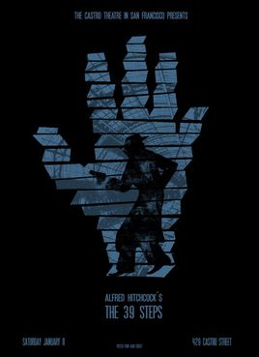
课外阅读：《The Thirty-nine Steps》作者：约翰·巴肯
出版社：新星出版社+参赛者：谢尚南+20191120714（学号）

when、where、who
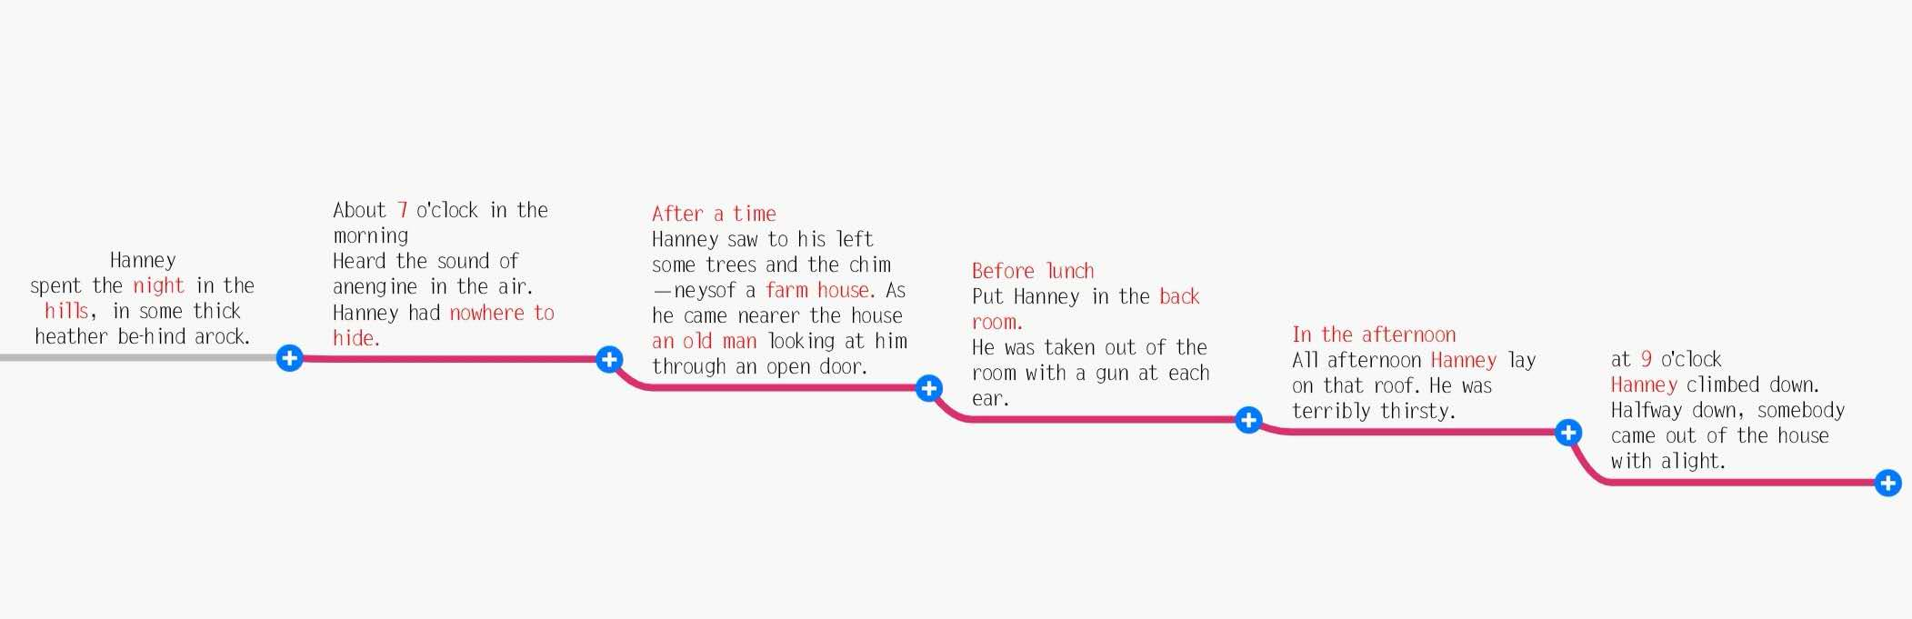
Synopsis of this chapter：
Hannay woke up at dawn to find that the enemies were coming soon. He jumped up immediately, then began a frantic run, and finally ran to a moorland farm.He thought he was lucky enough to be sheltered again, only to find himself in the enemy's nest!The old, sinister and shrewd gentleman, without listening to the story made up by Hannay, locked him up in a storeroom. Hannay finds explosives in the storeroom, and after an inner struggle and entanglement,he finally decides to detonate them in search of a slim chance of survival.He struggled to get up from the ruins after the explosion and stumbled out of the yard. Hannay, suffering great pain, climbed up to the dovecot to avoid the enemy's pursuit.Then,as night fell, Hannay climbed carefully down the dovecot and ran away from the accursed dwelling.

哈内在天亮时醒来，发现敌人马上就要来了。他一股脑地迅速跳起来，紧接着开始了疯狂逃亡，最终跑到了一座高原农舍里。他原以为可以再一次幸运地在这儿得到庇护，结果他发现自己居然走到敌人的老巢里来了！那个阴险又精明的老绅士没有听信汉内编造的故事，将他关押到了储藏室。汉内在储藏室里发现了炸药，在一番挣扎和纠结之后，他最终决定引爆炸药来寻求一线生机。汉内挣扎着从爆炸后的废墟中爬起来，跌跌撞撞地冲出了院子。他忍受着巨大的疼痛，爬到鸽房上面去躲避敌人的追捕。然后，夜幕降临，汉内小心翼翼地爬下鸽房，逃离了那栋可恶的房子。
Week six

The Thirty-nine Steps
Reading notes

Abstract——Excellent sentences:
1: It was a cold business, for I had neither coat nor waistcoat.
这一夜，我可冻得够呛，既没有外套，也没有背心
2: I supped off half those biscuits, and by worming myself deep into the heather got some kind of warmth. So far I had been miraculously lucky.
我掏出姜饼，慢慢地吃掉一半。然后爬进石南丛的深处，试图避点风寒。而且直到眼下，我的运气真是好得出奇。
3: I lay and tortured myself - for the ginger biscuits merely emphasized the aching void - with the memory of all the good food I had thought so little of in London.
吃下去的那点姜饼刚够吊起食欲，使我胃里更加像火燎似的空虚。我躺在草丛里，所有那些我在伦敦时不以为意的美味-----涌上心头，折磨得我一夜无法入眠。
4: I woke very cold and stiff about an hour after dawn.
天亮一个多钟头时我醒了，浑身冰凉而僵硬
5: I saw first the pale blue sky through a net of heather, then a big shoulder of hill, and then my own boots placed neatly in a blaeberry bush.
先是透过石南枝条望见淡蓝色的天空，继而是一个山头，然后看见我自己穿着靴子的脚，整齐地搁在草莓丛上。
6: I chose a ridge which made an angle with the one I was on, and so would soon put a deep glen between me and my enemies.
我挑选了一条与我所在的山梁成一定角度的山脊，这样很快我和敌人之间就有一条深沟隔着了。
7: I saw in front of me a sea of hills, rising very high towards the south, but northwards breaking down into broad ridges which separated wide and shallow dales.
眼前是无尽的高山，一直绵延到南方。北面则是一条条山脊，其间是一个个宽阔平缓的山谷。
8: I jumped the dyke and followed it, and after a few hundred yards - as soon as it was out of sight of the highway - the grass stopped and it became a very respectable road, which was evidently kept with some care.
我跳过堰墙，顺着小径一直走，走了好几百米，知道看不见公路的地方。从这里起，野草没有了，小径变成了一条十分漂亮的小路，显然有人精心养护。
9: It was well I did so, for no sooner had I gained the hollow than, looking back, I saw the pursuit topping the ridge from which I had descended.
我在这里走，是做对了，因为我刚下到溪边的低处，回头一望，就看见追我的警察正好出现在了我刚刚下来的坡顶上。
10: found a deserted cottage with a row of phantom peat-stacks and an overgrown garden.
沿途见到一座倾圯的农舍，旁边是一排幽灵似的泥炭垛，还有一座草木杂乱的花园。
11: Big glasses were stuck on the end of his nose, and the top of his head was as bright and bare as a glass bottle. There was something about the eye of the man before me, something so keen and knowledgeable, that I could not find a word. 一副大眼镜架在鼻梁上，头顶就像玻璃一样光秃、锃亮.我面前这个人的眼睛有些特别，显得既精明而又有学识，很难以形容。

The bald writer
Book report——personal feelings
Hanney had no choice but keep running. Although the environment around him is quite beautiful but he had no mood for enjoying. All his mind was filling with how to escape from the bad situation. But it seems like fate is against his wishes. The airplane above him, the police after him, the blackstone chase him. He had little time to rest and little choice to make. I wonder that if he will still accept this thing if he know the situation at the first place. His strong will is worth to respect. He's not doing this for himself, but for the whole country, for the world peace. Anyway, he is normal people, he never been to the army. He haven't give up yet. There is something charming on him, otherwise I can't understand why so many people trust him so easily. The old man must be someone important, he knew the identity of Hanney. It is brave of him to use the explosive risking his life, especially that he never use it before. But the situation now is more hard for him considering that the old man will join the team that chasing after him.
Abstract——key words
sup v.喝，呷；吃晚餐 n.一口；饮酒 miraculously adv.奇迹般地；神奇地 idiotic adj.白痴的；愚蠢的
inquest n.审讯；验尸；讯问 ginger n.姜；姜黄色；精力；有姜味 poach vt.偷猎；窃取；把…踏成泥浆
quart n.夸脱（容量单位）；一夸脱的容器 haste n.匆忙；急忙；轻率 revenge vt.报复；替…报仇；洗雪
slanted adj.斜的；有倾向的 ridge n.山脊；山脉；屋脊 pursue vt.继续；从事；追赶；纠缠
flank n.侧面；侧翼；侧腹 remnants adj.剩余的 hefty adj.重的；肌肉发达的；异常大的
pony adj.小型的；每日摘要的 dwell vi.居住；存在于；细想某事
hollow adj.空的；中空的，空腹的；虚伪的n.洞；山谷；窟窿vt.使成为空洞vi.形成空洞adv.彻底地；无用地
forsake v.抛弃；放弃，戒掉（喜爱的食物） scrubby adj.矮小的；树丛繁盛的 veranda n.走廊，游廊；阳台
stutter v.结结巴巴地说；突突地响 scrutinize vi.细阅；作详细检查
bid v.出价；叫牌；向……表示问候；（诗、文）命令；邀请；努力争取，企图获得；告诉，吩咐
flitch vt.切成鱼块；裁成板 betray vt.背叛；泄露（秘密） surliet adj.乖戾的；板面孔的，无礼的
sovereign adj.至高无上的；有主权的；有最高统治权的；不折不扣的 assurance n.保证，担保；（人寿）保险
chivvy vt.使烦扰；耍花招 oblige vt.迫使；施恩惠；责成； ordeal n.折磨；严酷的考验；痛苦的经验
hellish adj.地狱的；凶恶的；毛骨悚然的 impuse vi.利用；欺骗；施加影响 pistol n.手枪；信号枪
grope vi.摸索；探索 wraith n.幽灵；鬼魂；幻影 ghoulish adj.食尸鬼似的；令人毛骨悚然的
constabulary n.警察；警官队 owlish adj.看似聪明的；面孔严肃的 fortitude n.刚毅；不屈不挠；勇气
loop n.环状物、圈；弯曲的部分；环状结构；循环电影胶片；重复指令；环路 yank vi.猛地一拉
wrench vt.扭伤；猛扭；曲解； vague adj.模糊的；含糊的；不明确的 pluck n.胆识，勇气；内脏
detonator n.雷管；炸药；导火索 ensconced adj.安置好的；安居的 shuffle v.拖着脚走；把脚动来动去blister vt.使起水泡；痛打；猛烈抨击 gnaw vt.咬；折磨；侵蚀 acrid adj.（气味）辛辣的，苦的
staggered adj.错列的；吃惊的 ascent n.上升；上坡路；登高 fume v.对……十分恼火；冒烟，冒气
wriggle vi.蠕动；蜿蜒而行 haze n.阴霾；薄雾；疑惑

The bald writer

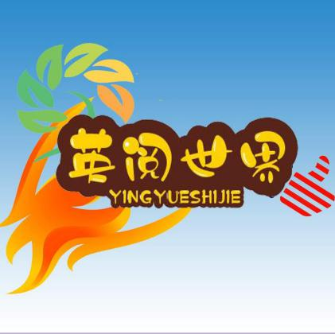
Favorite clip:

But it was a chance, the only possible chance. It was a mighty risk, but against it was an absolute black certainty. If I used it the odds were, as I reckoned, about five to one in favour of my blowing myself into the tree tops; but if I didn't I should very likely be occupying a six-foot hole in the garden by the evening. That was the way I had to look at it. The prospect was pretty dark either way, but anyhow there was a chance, both for myself and for my country.

译：但这是一个机会，我唯一的逃生机会。虽然非常冒险，但如果不冒这个险，那后果肯定就是死亡。我估计，如果我点燃炸药，十之八九会连自己也炸飞上天；但如果我不这样做，那今天晚上我则百分之百会被埋在花园中一个六尺见方的土坑里。事情就这么摆着：做和不做，前景都很可怕；但做了，总还有一定的成功机会，对我本人，对我的国家，都是如此。

The reason:
This passage is the psychological activities of Hannay when he was facing the choice of life and death. I think this plot is gripping. Hannay always dares totry. It was impossible for him to wait for death. Because he had no choice but to death if he did nothing. On the contrary, if he tried, he would have a chance to live. It was very lucky that Hannay finally escape from the dangerous place. Had Hannay given up trying, the story would have gone here, and it would have been a tragedy. The same applies to us, we may not really face a life-and-death choice, but there are some big things just like "the life-and-death choice" in daily life. If we can't be brave to try for ourselves, we will be full of tragedy.

Reason:

The bald writer

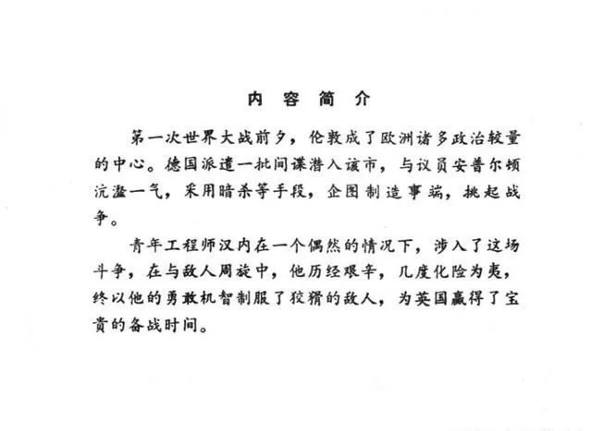
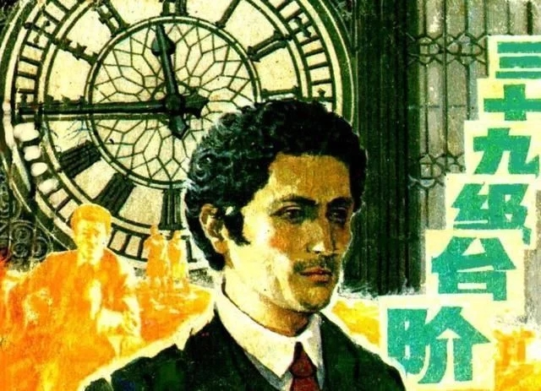
网址https://www.360kuai.com/pc/9a328198b318d13d3?cota=4&sign=360_57c3bbd1&refer_scene=so_1
Recommended today
Classic spy War Movie Comic Book: thirty nine steps, 1983 Edition
Thank you for watching
英阅小组:
English reading group：
赵怡 郜子涵 崔紫晗 李话雨 杨炳涛 谢尚南（source of content）
Editor：谢尚南
Tutoring；吴黄知老师

What one describes in the books is one's thought in his mind. The personality of a book is that of the author.
书迹即心迹，书品即人品。
阅经典，品智言，厚才学

Try and Try Hard
If you're going to try, go all the way.
Otherwise, don't even start.
If you're going to try, go all the way.
This could mean losing girlfriends, wives, relatives, jobs and maybe your mind.
Go all the way.
It could mean not eating for three or four days.
It could mean freezing on a park bench.
It could mean jail.
It could mean derision, mockery, isolation.
Isolation is the gift.
All the others are a test of your endurance, of how much you really want to do it.
And, you'll do it, despite rejection and the worst odds.
And it will be better than anything else you can imagine.
If you're going to try, go all the way.
There is no other feeling like that.

