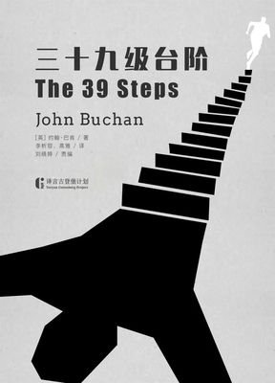
课外阅读：《The Thirty-nine Steps》作者：约翰·巴肯
出版社：新星出版社+参赛者：谢尚南+20191120714（学号）

when、where、who
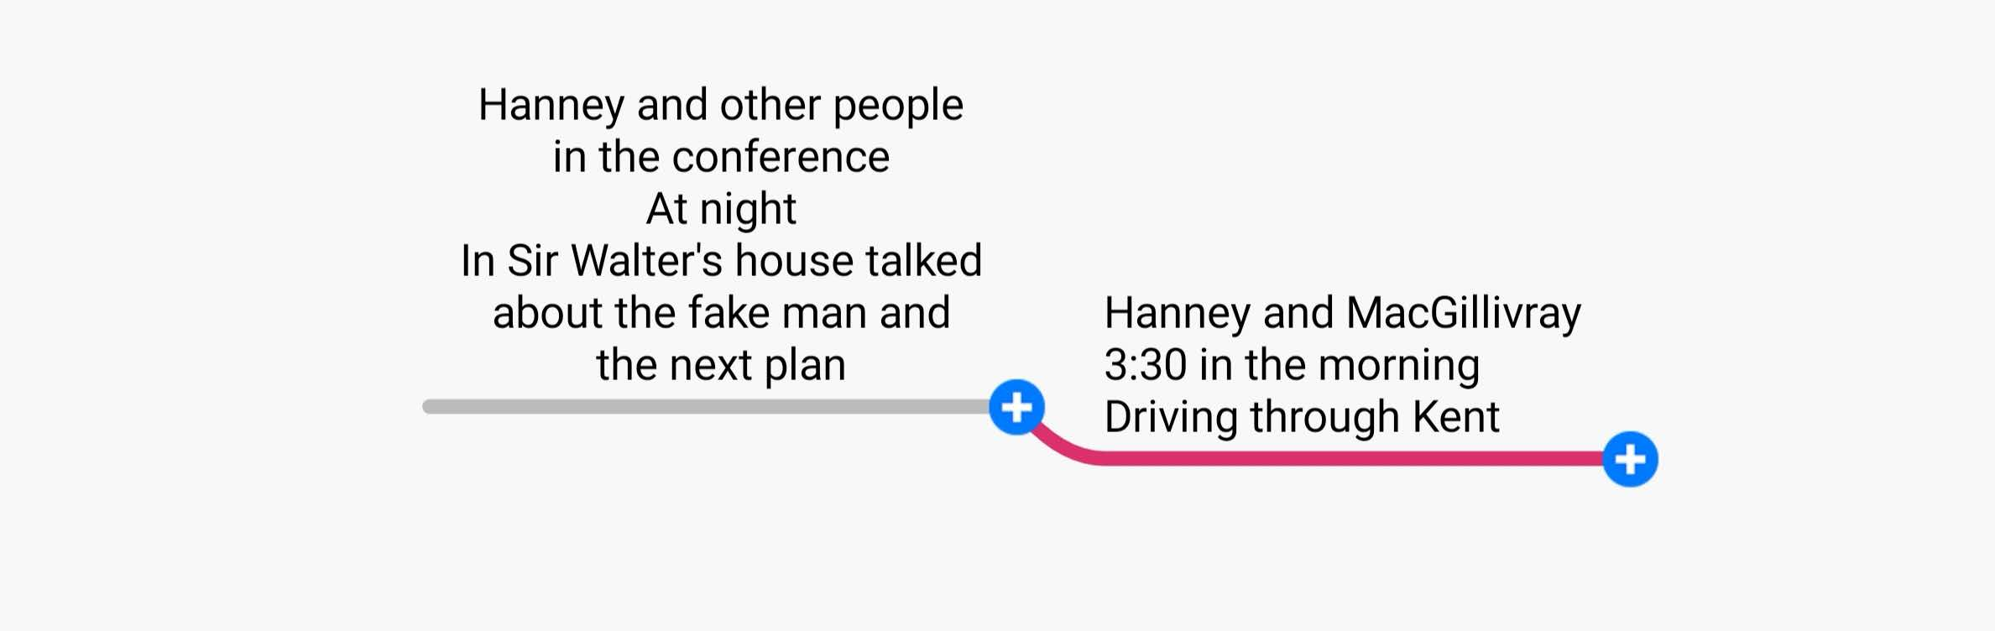
Synopsis of this chapter：
The 39 steps in this chapter are based on the conversation between Sir Walter and the protagonist Hannay. They discuss the behavior and spying of the first admiral. This prompted Hannay to immediately change the operational plan, otherwise intelligence is very useful to the enemy. The key clue of this chapter is that Scudder's small book records the contents of 39 steps, which is a big hint. He has not written down his thoughts on the contents of the notebook. The clue must be related to the rising tide time.

本章39级台阶以瓦尔特爵士和主人公哈内的交谈展开，他们探讨第一海军大臣的行为和刺探情况。这促使哈内必须立刻改变作战计划，否则情报对敌人非常有用。本章的关键线索斯卡德尔的小本里面记载了关于39级台阶的内容，这是一个很大的提示，还没写下了他对于笔记本中的内容的想法，线索一定与涨潮时间有关。
Week nine
The Thirty-nine Steps
Reading notes

Abstract——Excellent sentences:
1:The mare had been dead more than an hour, and the brute had been patiently watching me ever since.
小母马已经死了一个多小时，可那家伙一直耐心地在等着我。
2:If I could blunder thus, gentlemen, in a land where men's senses are keen, why should we busy preoccupied urban folk not err also?
想想看，在那种人人都很警惕的蛮荒地方，我尚且犯了这样的错误。那么，各位先生，我们在这城市环境中，又都忙得不可开交时，怎么可能不出错误呢？
3:The one thing that puzzles me,' said the General, 'is what good his visit here would do that spy fellow?
"我还有一件事不明白，"温斯坦利将军又说，“那个间谍来这里有什么用呢？
4:A good spy is trained to have a photographic memory.
一个优秀的间谍，脑子可以训练得像照相机一样。
5:Well, I can't speak with absolute assurance, but I'm nearly certain we can't make any serious change unless we alter the geography of England.
嗯，我不愿把话说得太绝对，但我几乎可以肯定：我们不可能对这个海军部署再做任何重大修改了，除非你能改变英国的版图本身。
6:No, my friends, I see no other way. The man who came here and his confederates must be taken, and taken at once.
怎么办，朋友们？我们别无选择，必须抓住这个家伙，抓住他的同伙，必须马上动手。
7:He receives personally his reward, and he delivers personally his intelligence.
他们总是亲自递交情报，也亲自领取奖赏。
8:Believe me, the need is desperate for both France and Britain.
相信我，这对法国和英国都是绝对必需的。
9:Where among the fifty millions of these islands and within a dozen hours were we to lay hands on the three cleverest rogues in Europe?
时间只剩下十几个小时了，我们怎么可能在全英国五千多万人中查出这三个全欧洲最狡猾不过的间谍来呢？我们该从哪儿着手呢？
10:The Admiralty man was looking at me as if he thought I had gone mad.
海军部高官惠塔克莫名其妙地瞪着我，好像在怀疑我脑子是不是出了毛病。
11:I sat at the desk and the others stood round, for somehow or other I had got charge of this expedition.
我马上坐到桌边埋头查阅，其他人便围站在我身边。就这样，自然而然，我成了这次行动的主导者。
12:If it was a harbour it must be some little place where the tide mattered, or else it was a heavy- draught boat.
看来，如果这地方是个港口，那就一定是个小港口，因而潮水的高低十分要紧。或者，所乘的就一定是艘吃水很深的大船。
13:It struck me as odd that I should be sitting at that desk with a Cabinet Minister, a Field-Marshal, two high Government officials, and a French General watching me, while from the scribble of a dead man I was trying to drag a secret which meant life or death for us.
眼下的状况真是有点奇怪。我现在坐在桌子前，在一个内阁部长、一个陆军元帅、两个英国政府高官和法国将军围观之下，正努力从一个死人留下的潦草手记中破解出对我们大家都性命攸关的秘密来。
14:Not that he or anybody else thought that that would do much good.
但无论是他或其他人，都知道这没有太大用处。
15:I lit a pipe and went over the whole thing again till my brain grew weary.
我点上烟斗，把整个事情在心里又理了一遍，直到脑子都累得疼了起来。

The Thirty-nine Steps

Book report——personal feelings
In chapter 9, the mystery of "the thirty-nine steps" finally comes to light and the location of the cunning enemy's escape is revealed.What is more amazing is that these knotty and exigent tasks were accomplished by an ordinary mining engineer.No, he is no longer an ordinary man, but a hero in my heart.
In this puzzle solving journey, the hero Hannay's incomparable capabilities were once again demonstrated.When they learned that the first naval minister who had just sat with them at the negotiating table had been disguised by German spies and had stolen state secrets, the top European officials panicked and wondered what to do.In a flash, Hannay thought of the uncanny clue left in Scudder's notebook -- The thirty-nine steps,I counted them,high tide 10.17 P. M.Then came our familiar strategist, Hannay, who had a rational mind and could dispassionately analyze.He thought hard about the clue of "thirty-nine steps" and began to brainstorm.Eventually,surrounded by the top officials all over Europe, Hannay came up with four fairly positive conclusions and three speculative ones.Through patient and careful questioning by coast guard inspectors who were familiar with the situation, hannay worked his way through the puzzle.Clear logic, rigorous thinking, Hannay was an amateurish decryption person, but he did better than a professional.These eminent gentlemen decided that Hannay was a man who could overcome difficulties and take on important responsibilities, so Hannay naturally became the commander-in-chief of this major operation.
The dawn of victory is at hand!
Abstract——key words
grumpy adj.脾气暴躁的；性情乖戾的 detect vt.察觉；发现；探测 granted conj.诚然
assembly n.装配；集会，集合 barbel n.触须；有触须的鱼；触须白鱼之类 whinny n.马嘶声
squeal v.告密；长声尖叫 tether n.系链；拴绳 tarpaulin n.柏油帆布；防水帽；防水衣；涂焦油
pistol n.手枪；信号枪 tawny adj.黄褐色的；茶色的
preoccupied adj.全神贯注的；心事重重的 fraud n.欺骗；骗子；诡计 acumen n.聪明，敏锐 taciturn adj.沉默寡言的；无言的，不太说话的 glum adj.忧郁的；死气沉沉的
confederate adj.同盟的，联合的； fumbler n.愚笨的人；摸索者
rogues n.流氓；小淘气；凶猛的离群兽 bureau n.局，处；衣柜；办公桌
snug adj.舒适的；温暖的 expedition n.远征；探险队；迅速
harbour n.海港，港口；避难所，安全港湾（同 harbor）
trawler n.拖网渔船；拖网捕鱼的人 yacht n.游艇，快艇；轻舟 scribble v.潦草（或匆忙）地写写
weary adj.疲倦的；厌烦的；令人厌烦的 naval adj.海军的；军舰 hedgerow n.灌木篱墙
The Thirty-nine Steps


Favorite clip:

All this was very loose guessing, and I don't pretend it was ingenious
or scientific. I wasn't any kind of Sherlock Holmes. But I have always
fancied I had a kind of instinct about questions like this. I don't know if I
can explain myself, but I used to use my brains as far as they went, and
after they came to a blank wall I guessed, and I usually found my guesses
pretty right.

译：所有这些，都只是不严密的猜测，我自己不认为他们有多么科学和严格。我更不是福尔摩斯那样的大侦探。但我的确常常觉得，我有解决这类难题的天赋。我不晓得我能否说得清楚，但我觉得我总能动脑筋尽量分析思考，当推理分析发挥到极致不再产生结果时，我就作猜测。而且我发现，我的这些猜测每每还相当正确。

Reason:

All great discoveries can not be separated from bold and logical thinking. Hanny thinks himself not Holmes, but he has the courage to discover new things and bold and reasonable imagination. This shows that Hanne's escape not only by the luck and the help of others, but also depends on his personal abilities.He is good at finding a way for himself with the help of the surrounding environment, and he relies on careful thinking and observation to escape the enemy again and again. This shows that: when we are in adversity, only can we be good at using the external forces of the surrounding environment and our own personal efforts, we can get out of the negative situation.

The Thirty-nine Steps

Pride Goes before a Fall
There was a proud teak tree in the forest. He was tall and strong.
There was a small herb next to the tree.
The teak tree said, "I am very handsome and strong. No one can defeat me."
Hearing this, the herb replied, "Dear friend, too much pride is harmful. Even the strong will fall one day."
The teak ignored the herb's words. He continued to praise himself.
A strong wind blew. The teak stood firmly.
Even when it rained, the teak stood strong by spreading its leaves.
During these times, the herb bowed low. The teak made fun of the herb.
One day, there was a storm in the forest. The herb bowed low. As usual, the teak did not want to bow.
The storm kept growing stronger. The teak could no longer bear it. He felt his strength giving way.
He tried his best to stand upright, but in the end, he fell down. That was the end of the proud tree.
When everything was calm again, the herb stood straight. He looked around. He saw that the proud teak had fallen.
Moral: Pride goes before a fall.
今日分享
Thank you for watching
英阅小组:
English reading group：
赵怡 郜子涵 崔紫晗 李话雨 杨炳涛 谢尚南（source of content）
Editor：谢尚南
Tutoring；吴黄知老师

What one describes in the books is one's thought in his mind. The personality of a book is that of the author.
书迹即心迹，书品即人品。
阅经典，品智言，厚才学

憔悴的心穿过眼眸
透视那如日的温暖
灵魂布满怀旧的颜色
灰色的光反射出懒惰的神情
我在睡梦中
灵魂不断飘升飘升
但拒绝抚摸那些陌生的动作
远方的路
被离愁扯得远而又远
在天空
我啄着你的名字
成熟的味道
仿佛一片落叶的记忆
走入温暖的春季
用笑脸渲染我的梦
看一眼怒放的迎春花
抖落一地的斑斓

