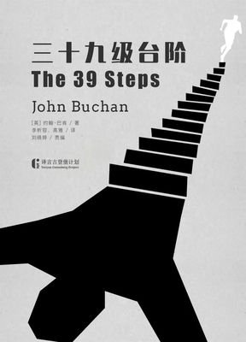

课外阅读：《The Thirty-nine Steps》作者：约翰·巴肯
出版社：新星出版社+参赛者：谢尚南+20191120714（学号）

Chapter eight——when、where、who
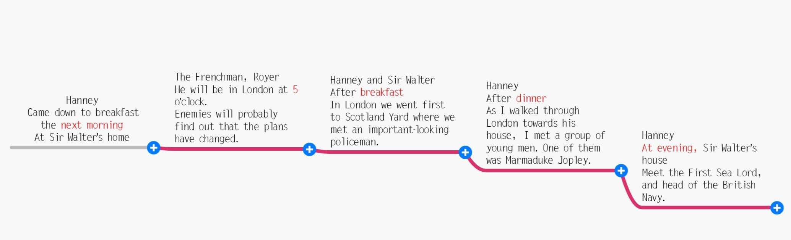
Synopsis of this chapter：
After a full eight hours' sleep, Sir Walter told Hannay of his plans and plans. Sir Walter took Hannay to Scotland and asked the police officer to guarantee his freedom. Hannay, who had become a free man, was not used to the sudden freedom, and he was still surrounded by a nervous mood. Walking down Jermin street, Hannay was mistaken for the murderer again. He ran as hard as he could to queen Anne's arch. He discovered the enemy's plot in time.It's found that it's not Sir Arroya, but "black stone".

整整八个小时的睡眠过后，瓦尔特爵士向汉内滔滔不绝得讲述各种部署以及周密的计划。瓦尔特爵士带着汉内来到苏格兰，要警官保证汉内的自由。成为自由人的汉内却不习惯这突如其来的自由，他仍被惴惴不安的情绪环绕。走在杰尔明大街上，汉内又被误认凶手，他拼尽全力跑到安妮女王拱门。他及时发现了敌人的阴谋。发现了走根本不是阿洛亚爵士而是“黑石头”
Week eight
The Thirty-nine Steps
Reading notes

Abstract——Excellent sentences:
1.While I ate he continued to talk,making me to my surprise a present of his full confidence.
我低头吃着，他就这样不停地说，把许多机密都说了出来,我为他对我的完全信任感到意外。
2.If I were you I would go to bed,for you must have considerable arrears of sleep to overtake.
我要是你，我现在就去睡觉,你肯定已欠了很多觉，需要好好补一补了。
3.I felt the sense of danger and impending calamity,and I had the curious feeling,too,that I alone could avert it,alone could grapple with it.
我感觉到深重的危机和迫在眉睫的灾难，我有一种奇怪的感觉，觉得唯有我才能力挽狂澜，只有我能够化解这场灾难。
- I felt that I wanted enormously to have a vulgar scrap with those gentry,where I could hit out and flatten something.
我迫切希望现在能和这些家伙狠狠地干上一仗，拼个鱼死网破就好了。
- Here was I,a very ordinary fellow,with no particular brains,and yet I was convinced that somehow I was needed to help this business through—that without me it would all go to blazes.
我就是这样，一个很普通的人，说不上有什么特别的智慧和才能，但我却深信这件事情必须有我才行，少了我，事情就会一败涂地。
- It seemed as if a voice kept speaking in my ear,telling me to be up and doing,or I would never sleep again.
我耳边好像总有一个声音在说：快点行动起来，快点行动起来，否则你一辈子都会后悔莫及！
- Exasperation and an overwhelming sense that at no cost must I delay gave me the strength of a bull elephant.
我恼怒至极，而且无论如何也不能再耽误时间了,这使我浑身产生一股牛劲。
8. He opened the door,and with a face like a graven image waited to be questioned.
管家神情镇定得叫人叹服，他面无表情地打开门，像一尊雕塑一样冷冷地站着，等候门外的来人发问。
9. You couldn't open a newspaper or a magazine without seeing that face.
当今之日，你只要打开报纸或杂志，大半就会看到这张面孔。
- You can't mistake it. It is a flicker,a spark of light,a minute shade of difference which means one thing and one thing only.
毫无疑问！就是他眼睛里的这丝火花，这眼神的些微异样，表明他有某种重要的内心活动。
The coming of the black stone
Book report——personal feelings
By far, the plot is very close to the climax. The author is obviously very creative. Each time the story always have a unexpectable turn. I start to wondering that maybe the story will end with the death of Hannay. Because that way he will be more like a hero. But who knows? Anyway, the interesting part of this chapter is that with all the senior leaders so close to the fake Lord Alloa, not even one person doubt his identity. It's unusual that nobody knows the appearance of such a famous man. It could be that there is another spy among them, it will appear by the end of the story or at some important. But it's glad that the government has noticed about the situation and takes it seriously. Sir Walter is my second favorite character in the story, Because he trust hanney, a nobody, and his story. With such a wise person leading them, the conspiracy of the blackstone won't be achieved.
The coming of the black stone
Abstract——key words
de·code v. /ˌdiːˈkəʊd/解；破译（尤指密码） midst n. /mɪdst/ 中部；中间 muf·fin n. /ˈmʌfɪn/ 英格兰松饼mar·ma·lade n. /ˈmɑːməleɪd/橘子酱 rosiness n./'rəʊzɪnɪs/ n. 愉快;蔷薇色 tar·nish v. /ˈtɑːnɪʃ/失去光泽Chief n. /tʃiːf/ 首领，头目，最高领导人 army/industry/police chiefs 部队首长；行业巨擘；警察局长
the First Lord海军第一大臣 the Secretary for War陆军部部长 wire n. /ˈwaɪə(r)/ 金属丝；金属线
clinch v. /klɪntʃ/ 成功取得；赢得 ar·range·ment n. /əˈreɪndʒmənt/ 安排；筹备 leak n. /liːk/ 秘密信息的透露
disposition n. /ˌdɪspəˈzɪʃn/ 排列布置 im·mense adj. /ɪˈmens/ 极大的；巨大的 al·ter·ation n. /ˌɔːltəˈreɪʃn/ 改变
child·ish adj. /ˈtʃaɪldɪʃ/ 幼稚的；天真的 row n /raʊ/ 严重分歧；纠纷 stick v. /stɪk/ 粘贴；粘住
stick by sb 坚持忠于；不离弃（某人） scheme n./skiːm/ 计划；方案；体系；体制/ 阴谋；诡计；计谋
reckon v. /ˈrekən/ 想；认为 destroyer n. /dɪˈstrɔɪə(r)/ 驱逐舰 Havre n 勒阿弗尔（法国港市
Miscarriage n. /ˈmɪskærɪdʒ/ 流产 deuce n. /djuːs/ 见鬼！; 糟了！ Chancelleries n. /ˈtʃɑːnsələri/ 大臣官邸
Chauffeur /ˈʃəʊfə(r)/ n.（尤指富人或要人的）司机 Rig /rɪɡ/ n. 服装 retreat n./rɪˈtriːt/ 僻静处；隐居处
a country retreat乡间幽静的住所 overworked adj. /ˌəʊvəˈwɜːkt/ 工作过多的 sultriness n./ˈsʌltrinəs/ n. 纵情声色
punctually ad. /ˈpʌŋktʃuəli/ adv. 准时地，如期地 butler n. /ˈbʌtlə(r)/ 男管家 prim adj. /prɪm/ 一本正经的
clean-shaven /ˌkliːn ˈʃeɪvn/ adj. 胡子刮净的；刮过脸的 mur·der·er n. /ˈmɜːdərə(r)/ 杀人犯；杀人凶手
wry adj. /raɪ/ 挖苦的；讽刺的；揶揄的 presume v. /prɪˈzjuːm/ 假设；假定 grave a. /greɪv/ 严重的
edify v. /ˈedɪfaɪ/教化；启迪 in·con·veni·ence n. /ˌɪnkənˈviːniəns / 不便 assurance n. /əˈʃʊərəns; əˈʃɔːrəns/ 保证
promptly adv. /ˈprɒmptli/ 迅速地 exculpation /ˌekskʌlˈpeɪʃn/ n. 辩解 deadly ad. /ˈdedli/ 极其；非常
Luncheon n. /ˈlʌntʃən/ 午餐，午宴 Lounge n. /laʊndʒ/ 等候室 ter·race n. /ˈterəs/（相同的一排）排房
slum n. /slʌm/ 贫民窟；棚屋区 im·pend·ing adj. /ɪmˈpendɪŋ/ 即将发生的的 ca·lam·ity n. /kəˈlæməti/ 灾难
avert v. /əˈvɜːt/ 防止，避免 grap·ple v. /ˈɡræpl/ 努力设法解决 vulgar adj. /ˈvʌlɡə(r)/ 庸俗的；粗俗的
scrap n. /skræp/ 打架；争吵 gentry n. /ˈdʒentri/ 绅士阶层 abom·in·able adj. /əˈbɒmɪnəbl/ 令人憎恶的
sheer a. /ʃɪə(r)/ 完全的；纯粹的；十足的 con·ceit n. /kənˈsiːt/ 自负；骄傲自大 upshot n. /ˈʌpʃɒt/ 最后结果
ease /iːz/ 宽慰；减轻；缓解 imbecile a. /ˈɪmbɪsiːl/ 愚蠢的; 笨的 gutter n. 贫民窟 rage /reɪdʒ/ 暴怒
constable n./ˈkʌnstəbl/ (英国等国家中级别最低的) 警官 wigging n./ˈwɪɡɪŋ/ 谴责 crool v./kruːl/ 糟蹋
Wrench v. /rɛntʃ/ 挣脱 jiffy n. /ˈdʒɪfi/ 一会儿；瞬间 dodge v. /dɒdʒ/ 闪开；躲开；避开
press n. /pres/ 拥挤的人群（或大批事物） spurt /spɜːt/ 短时激增，迸发 briskly adv. 迅速地
pant pant v. /pænt/ 气喘；喘息 al·cove n. /ˈælkəʊv/ 壁凹 furi·ous adj./ˈfjʊəriəs/ 狂怒的；暴怒的
graven a./ˈɡreɪvən/ 不可磨灭的 spade n. /speɪd/ 锹；铲 usher v. /ˈʌʃə(r)/ 把…引往；引导；引领
creep /kriːp/ 悄悄地缓慢行进 flicker /ˈflɪkə(r)/ 摇曳，闪烁，忽隐忽现 involuntarily adv. 无心地；
maze n. /meɪz/ 迷宫


Favorite clip:
Here was I, a very ordinary fellow, with no particular brains, and yet I was convinced that somehow I was needed to help this business through - that without me it would all go to blazes. I told myself it was sheer silly conceit, that four or five of the cleverest people living, with all the might of the British Empire at their back, had the job in hand. Yet I couldn't be convinced. It seemed as if a voice kept speaking in my ear, telling me to be up and doing, or I would never sleep again.

译：我就是这样，一个很普通的人，说不上有什么特别的智慧和才能，但我却深信这件事必须有我才行，少了我，事情就会一败涂地。我也试图说服自己：你这样想其实很可笑，人家这里有四五个聪明绝顶的人物在运作，又有整个大英帝国的国家机器做后盾，哪里会就缺了你一个？但是，我仍旧说服不了自己。我耳边好像总有一个声音在说：快点行动起来，快点行动起来，否则你一辈子都会后悔莫及！

Reason:
Hannay knew he was just a little man, but after all this experience, he was reluctant to give up. Hannay is willing to risk his life to defend his country's interests. Meanwhile, for the sake of faith in his heart, promised Scudder to do it, the task seems to have become his mission. Although Hannay knew that national security could not be tied to a small man like him, and he even thought his ideas were ridiculous, he remained unrepentant.As he said to himself, if he gave it up, he might regret throughout his life. So he insisted on doing it, no matter what will happen, the result is worthy of heart.

The coming of the black stone

今日推荐
An Invincible Summer
我的心里有一个不可战胜的夏天
My dear,
In the midst of hate, I found there was, within me, an invincible love.
In the midst of tears, I found there was,
within me, an invincible smile.
In the midst of chaos, I found there was,
within me, an invincible calm.
I realized, through it all, that…
In the midst of winter, I found there was,
within me, an invincible summer.
And that makes me happy.
For it says that no matter how hard the world pushes against me, within me, there's something stronger — something better, pushing right back.
Truly yours,
Albert Camus
Thank you for watching
英阅小组:
English reading group：
赵怡 郜子涵 崔紫晗 李话雨 杨炳涛 谢尚南（source of content）
Editor：谢尚南
Tutoring；吴黄知老师

What one describes in the books is one's thought in his mind. The personality of a book is that of the author.
书迹即心迹，书品即人品。
阅经典，品智言，厚才学

《寻找夏天》
沿着山间小路
来到瓜地 果场
释放一些汗水和泪水
叩问大地 自摘自买
其乐无穷 入夜
你还甘于寂寞吗
城市的霓虹灯烁着
灵水一游 凉意上心头
农村村头大榕树下
围着纳凉的人们
夏天在哪里
就在你的意愿里
不是夏天来找你
而是你去寻找夏天

